**Title: Fake News Detection Using Natural Language Processing**

**Business Problem**

The widespread circulation of false or misleading news online is a growing concern that can distort public opinion and damage democratic institutions. Manual fact-checking is not scalable given the sheer volume of digital content. This project addresses the urgent need for an automated solution to detect misinformation using Natural Language Processing (NLP) and machine learning. The proposed system classifies news articles as real or fake based on their textual content, serving as an initial filter to flag suspicious articles for human review.

**Background/History**

While fake news is not new, the rise of digital platforms has exponentially increased its reach. Misleading stories can now spread globally within minutes, often faster than corrections. In response, automated techniques using NLP and machine learning have gained traction. This project applies proven methods to evaluate the feasibility of a scalable fake news detection system.

**Data Explanation**

This section details the dataset used for this project, including its acquisition, structure, and the comprehensive preprocessing steps undertaken to prepare the text for machine learning analysis.

**Data Acquisition and Structure**

This project utilized the **"**[**Fake and Real News Dataset**](https://www.kaggle.com/datasets/clmentbisaillon/fake-and-real-news-dataset)**"** from Kaggle, which comprises two distinct datasets: one containing "fake" news articles and another with "true" news articles. Key columns across these datasets include title, text, subject, date. The title and text columns were concatenated to form a single 'text' feature for unified analysis.

**Data Preprocessing**

Converting raw text into a machine-readable format is crucial for NLP. Our preprocessing pipeline cleaned and normalized the text to enhance feature extraction. This involved:

1. **Lowercasing** all text.
2. **Removing punctuation** and special characters.
3. **Normalizing whitespace**.
4. **Removing common English stop words** (e.g., "the", "is") using NLTK.
5. **Lemmatization** using NLTK's WordNetLemmatizer to reduce words to their base form (e.g., "running" to "run"), preserving semantic meaning and reducing the feature space.

**Exploratory Data Analysis (EDA)**

EDA was conducted to understand the dataset's characteristics and identify patterns differentiating real from fake news after preprocessing.

* **Class Distribution:** The count plot titled "Distribution of Real vs Fake News" shows a nearly balanced dataset (approx. 22,000 fake, 21,000 real articles), beneficial for model training.

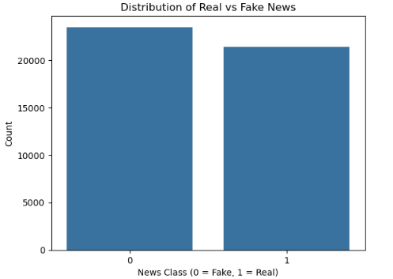

* **Text Length Distribution:** The histogram titled "Text Length Distribution by Class" indicates that while both types vary in length, fake news often clusters at shorter lengths, suggesting more concise or clickbait content.

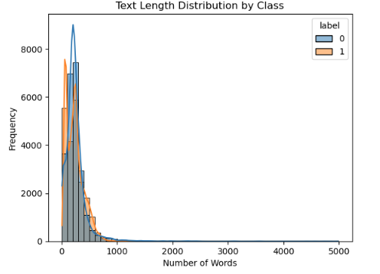

* **Word Clouds:** To visually demonstrate preprocessing effectiveness and distinct vocabulary patterns, word clouds were generated for both cleaned real and fake news articles. After processing, these word clouds showed meaningful terms, with stop words successfully removed.

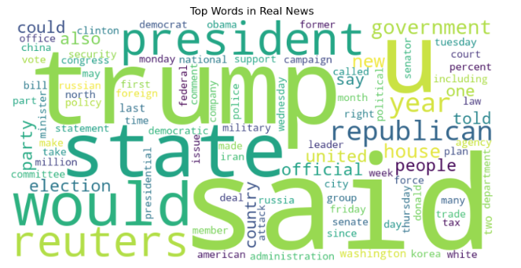

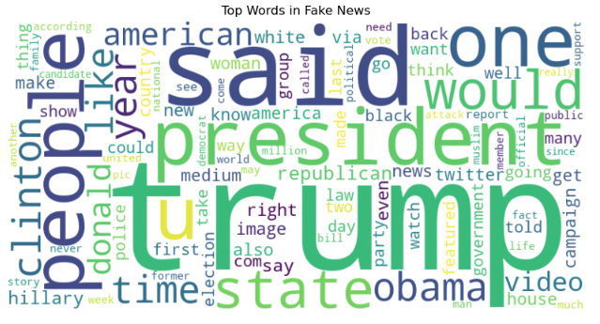

The clear distinction in vocabulary after cleaning confirmed successful text transformation.

**Methods**

This section outlines the methodological approach employed, covering feature engineering techniques and the selection of machine learning models.

The task is framed as a **binary text classification problem**, aiming to classify news articles as "Fake News" (label 0) or "Real News" (label 1).

**Feature Engineering**

**TF-IDF (Term Frequency-Inverse Document Frequency)** vectorization was used to convert processed text into numerical features. This method weights words based on their frequency in a document and rarity across the corpus, highlighting important terms. The TfidfVectorizer was configured with max_features=5000 (top 5,000 terms) and ngram_range=(1,2) (unigrams and bigrams) for dimensionality reduction and contextual capture.

**Model Selection**

This project comparatively evaluated four machine learning classifiers effective in text classification:

1. **Logistic Regression:** A linear, interpretable, and efficient model.
2. **Multinomial Naive Bayes:** A probabilistic classifier strong for discrete features.
3. **Random Forest Classifier:** An ensemble method combining multiple decision trees for improved accuracy.
4. **Linear Support Vector Machine (Linear SVM):** A powerful linear classifier that finds an optimal hyperplane to separate classes, effective in high-dimensional spaces.

**Training and Evaluation Strategy**

The dataset was split into training (67%) and test (33%) sets using train_test_split with random_state=42 and stratify=y to ensure reproducibility and balanced class representation. Models were evaluated using accuracy, precision, recall, F1-score, and confusion matrices. To support generalizability, 5-fold cross-validation was conducted, with mean and standard deviation of scores reported across folds.

**Analysis**

This section presents and interprets model results, including feature importances, to explain observed accuracies.

**Initial Model Evaluation Results**

|  |  |  |  |  |  |  |  |
| --- | --- | --- | --- | --- | --- | --- | --- |
| **Model Name** | **Accuracy** | **Precision (0)** | **Recall (0)** | **F1-Score (0)** | **Precision (1)** | **Recall (1)** | **F1-Score (1)** |
| **Logistic Regression** | **0.9898** | **0.99** | **0.99** | **0.99** | **0.99** | **0.99** | **0.99** |
| **Naive Bayes** | **0.9455** | **0.95** | **0.95** | **0.95** | **0.94** | **0.94** | **0.94** |
| **Random Forest** | **0.9982** | **1.00** | **1.00** | **1.00** | **1.00** | **1.00** | **1.00** |
| **Linear SVM** | **0.9957** | **1.00** | **1.00** | **1.00** | **0.99** | **1.00** | **0.99** |

All models performed well, indicating clear class separability. Logistic Regression, Random Forest, and Linear SVM showed accuracies of 0.9898, 0.9982, and 0.9957, respectively. Naive Bayes had a lower accuracy of 0.9455 with more misclassifications.

Feature importance analysis revealed that terms like “reuters” and “washington reuters” were strong indicators of real news, while words such as “via,” “video,” and “image” were more common in fake news. These patterns were consistently leveraged across models. For detailed model evaluation results and the top features used by each classifier, please refer to **Appendix A**.

**Cross-Validation Insights**Cross-validation confirmed the reliability of these results. These findings further support the presence of strong, consistent patterns in the data, as shown in the detailed breakdowns in **Appendix A.**

**Conclusion**

This project demonstrates the potential of using machine learning and natural language processing to detect fake news. Among the models tested, Random Forest showed the strongest performance, effectively identifying patterns in language and source references. While the results are promising, real-world applications remain challenging due to the ever-changing nature of misinformation. Automated detection systems must be implemented with ethical care and human oversight. Overall, this work offers a solid foundation for understanding model behavior and guiding future efforts in combating fake news.

**Assumptions, Limitations and Constraints**

This project used the Kaggle Fake and Real News dataset to classify news articles using NLP and machine learning. The work assumes that:

* The dataset reflects common fake/real news patterns of its time.
* Articles are in English and contain enough information in the title and text fields.
* The binary labels (fake/real) are accurate and sufficient.
* Key features identified in this project remain relevant over time.

**Limitations** include:

* **Dataset specificity:** The high accuracy likely results from clear, dataset-specific cues that may not generalize to other contexts.
* **Feature depth:** TF-IDF captures surface-level patterns but misses nuance, tone, and sarcasm.
* **Model scope:** Traditional models may underperform compared to deep learning approaches.
* **Static data:** The model hasn't been validated on current or evolving fake news content.

**Challenges** faced:

* NLTK setup issues required manual fixes.
* Cross-validation was computationally heavy, especially with Random Forest.
* High accuracy demanded careful interpretation to avoid overconfidence.
* Choosing the right preprocessing methods involved trade-offs between speed and performance.

### **Future Uses and Recommendations**

This project lays the groundwork for practical fake news detection tools that can aid in content moderation, support fact-checkers, and promote media literacy. Future enhancements should include the use of advanced deep learning models like BERT and RoBERTa to better capture contextual meaning, along with updating datasets for broader and more current representation. Incorporating non-text features such as images or source credibility, as well as implementing continuous retraining, will improve robustness. Human oversight remains critical to ensure the system stays ethical, transparent, and responsive to the ever-changing landscape of misinformation.

**Implementation Plan**:

To bring the fake news detection system into practice, the initial step would involve refining the current machine learning models. If resources allow, deep learning models like BERT can be explored for improved contextual understanding. A real-time detection API will be developed to flag suspicious content, featuring explainability tools such as confidence scores and keyword highlights. To maintain performance over time, the system will support continuous learning through regular retraining with updated data. A small-scale pilot deployment will help validate the system’s effectiveness and gather feedback for future enhancements.

**Ethical Considerations**

Automated fake news detection involves several key ethical concerns:

**Data Bias**: Heavy reliance on features like "reuters" could introduce bias, misclassifying legitimate news without such markers or missing subtle misinformation.

**Defining “Fake News”**: The term is subjective—models may mistakenly flag satire, opinion, or parody, raising concerns about misclassification.

**Censorship Risks**: Overconfident systems may suppress valid content, threatening freedom of speech and access to information.

**Adversarial Attacks**: Malicious actors could exploit model weaknesses by mimicking credible content or avoiding known indicators.

**Need for Human Oversight**: Models should assist, not replace, human fact-checkers. A human-in-the-loop approach ensures more ethical and accountable outcomes.

**References**

*fake-and-real-news-dataset*. (2024, April 19). Kaggle. https://www.kaggle.com/datasets/clmentbisaillon/fake-and-real-news-dataset

*scikit-learn: machine learning in Python — scikit-learn 1.7.0 documentation*. (n.d.). https://scikit-learn.org/stable/

Aldwairi, M., & Alwahedi, A. (2018). Detecting fake news in social media networks. *Procedia Computer Science*, *141*, 215–222. <https://doi.org/10.1016/j.procs.2018.10.171>